AWS cloud9 tutorial :

<https://www.youtube.com/watch?v=FvclLeg2vEQ>

This one is best one down one:

<https://www.youtube.com/watch?v=u1D1KVECjiY>

I have created cloud-9 on TR network –GauravLambda

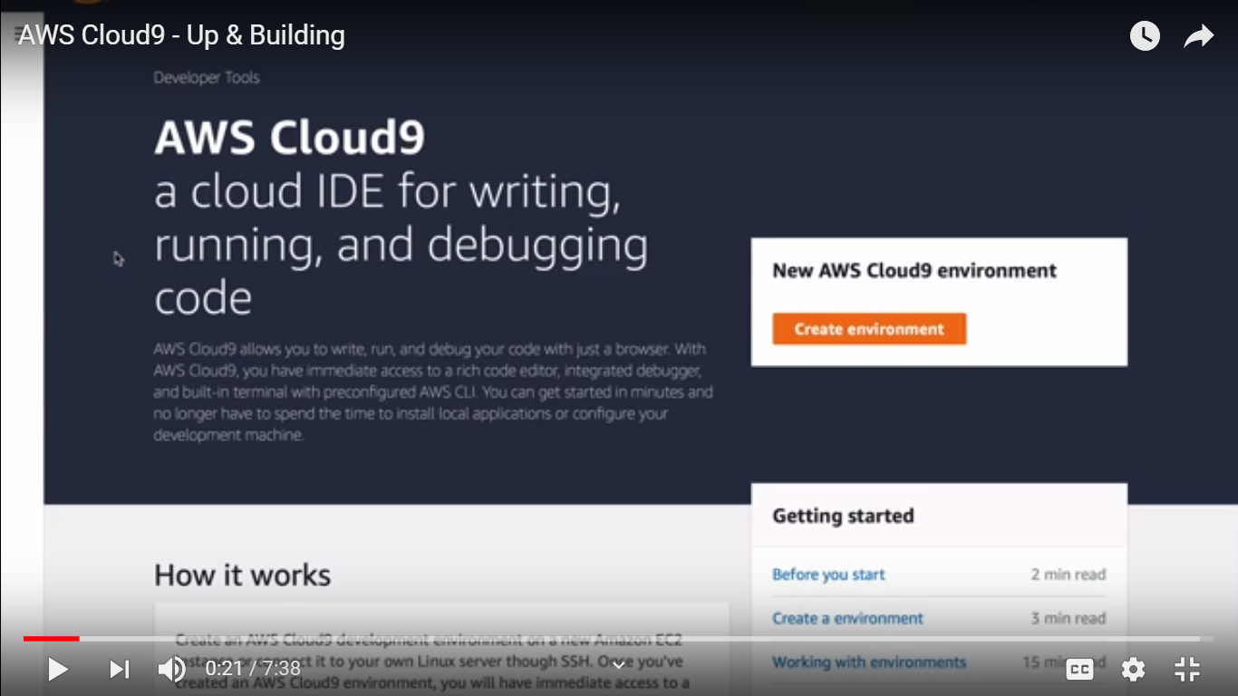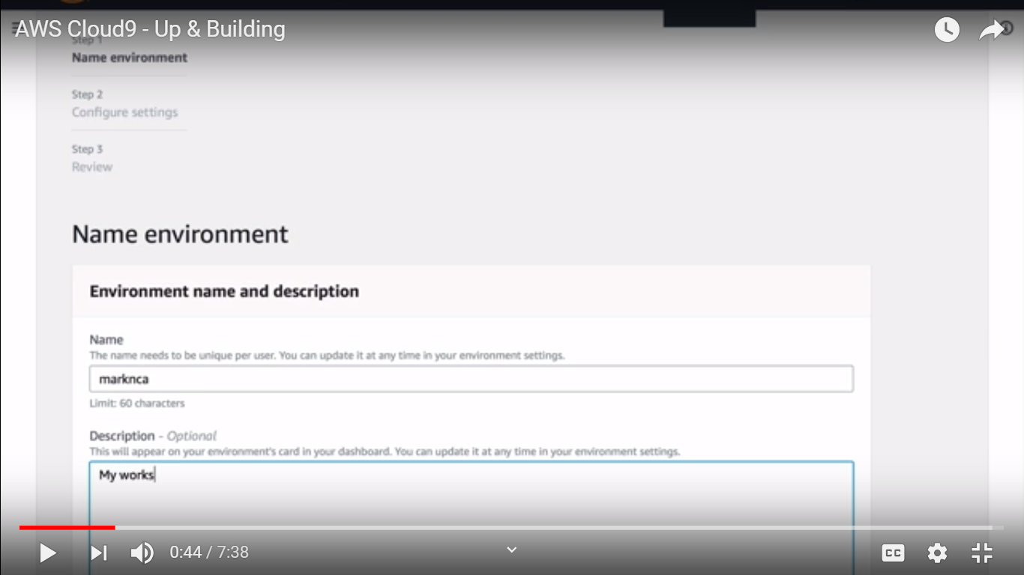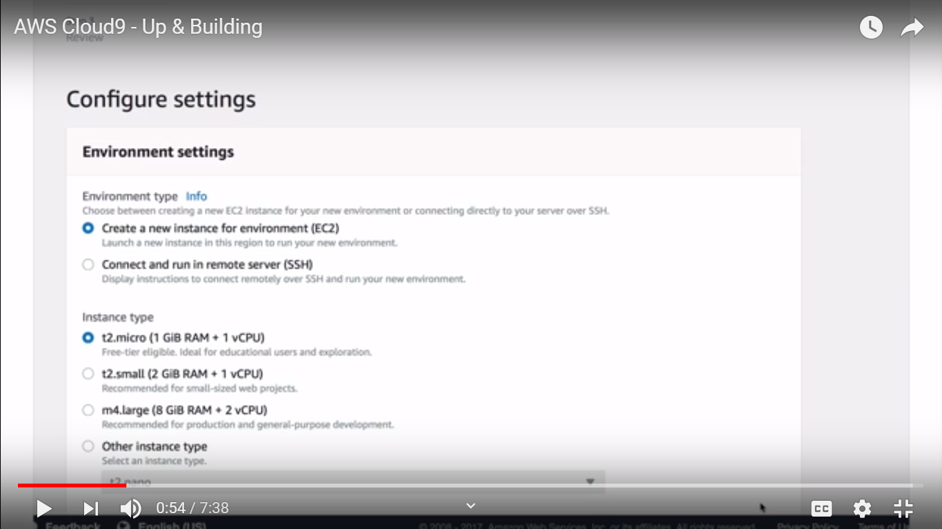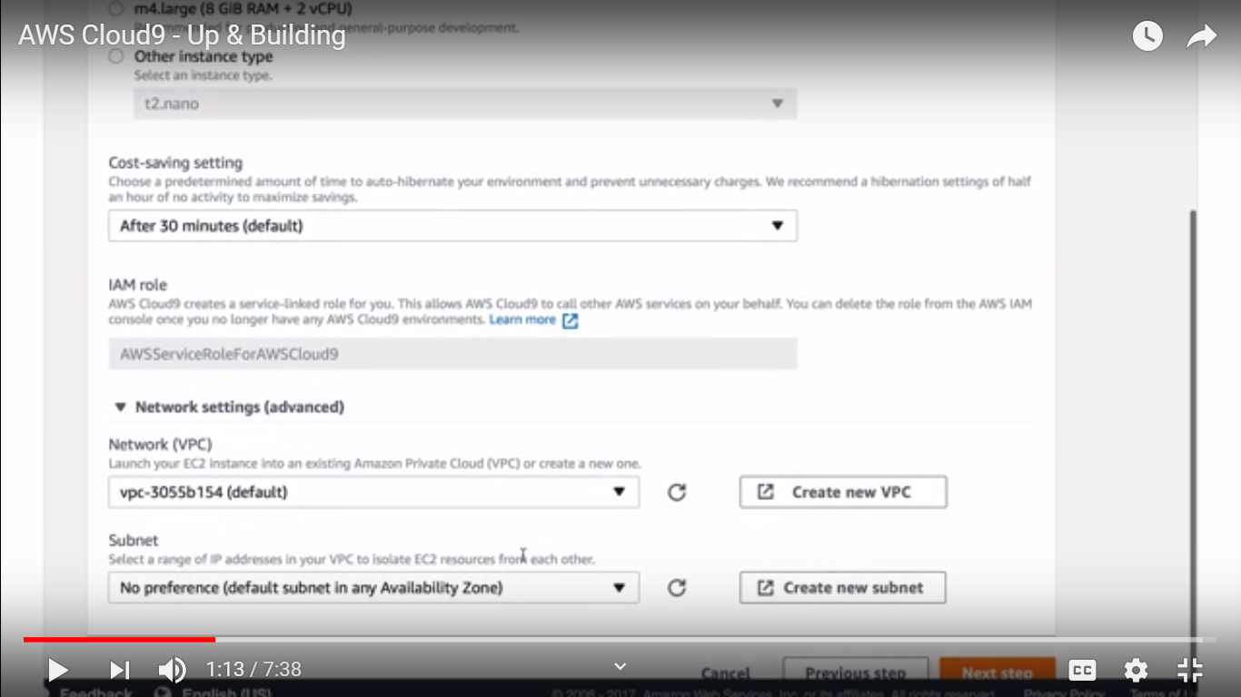

In my case in TR network its taking default VPC and subnet with same I can able to see in lamabada

